**Program Title : SERVO Motor**

**Aim : Design IR based SERVO Motor controller. (Clockwise and AntiClockwise rotation of shaft)**

Hardware Required:

* Arduino Board
* SERVO Motor
* IR sensor
* IR remote

**Circuit Diagram :**

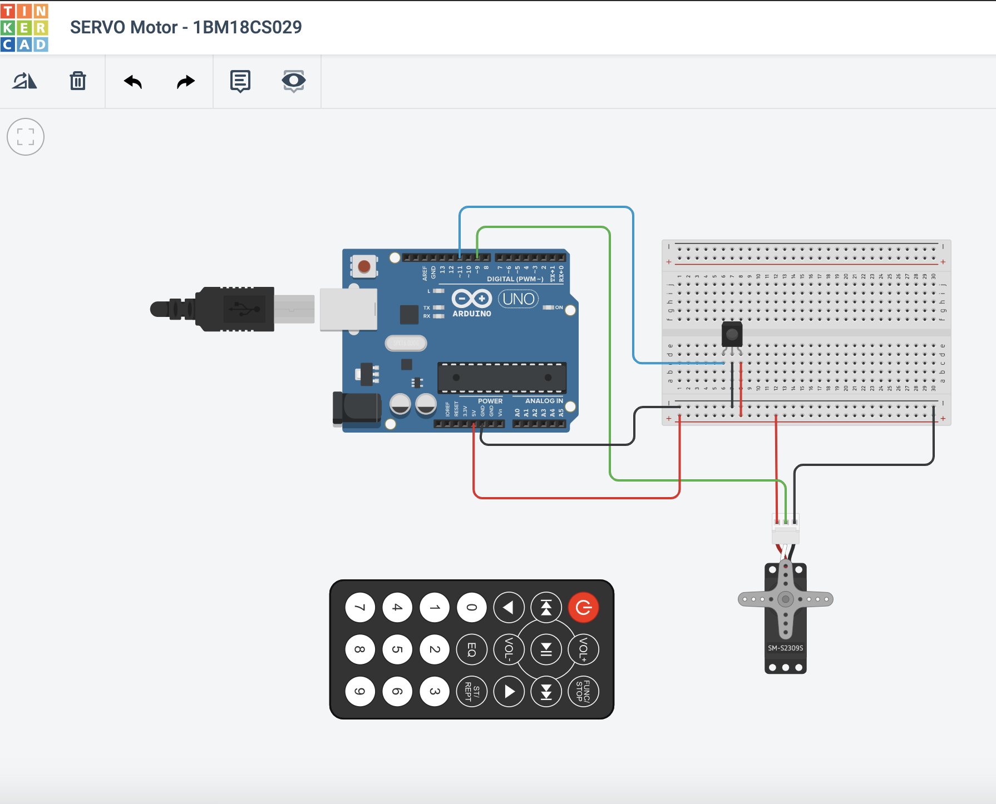

**Output/Working :**

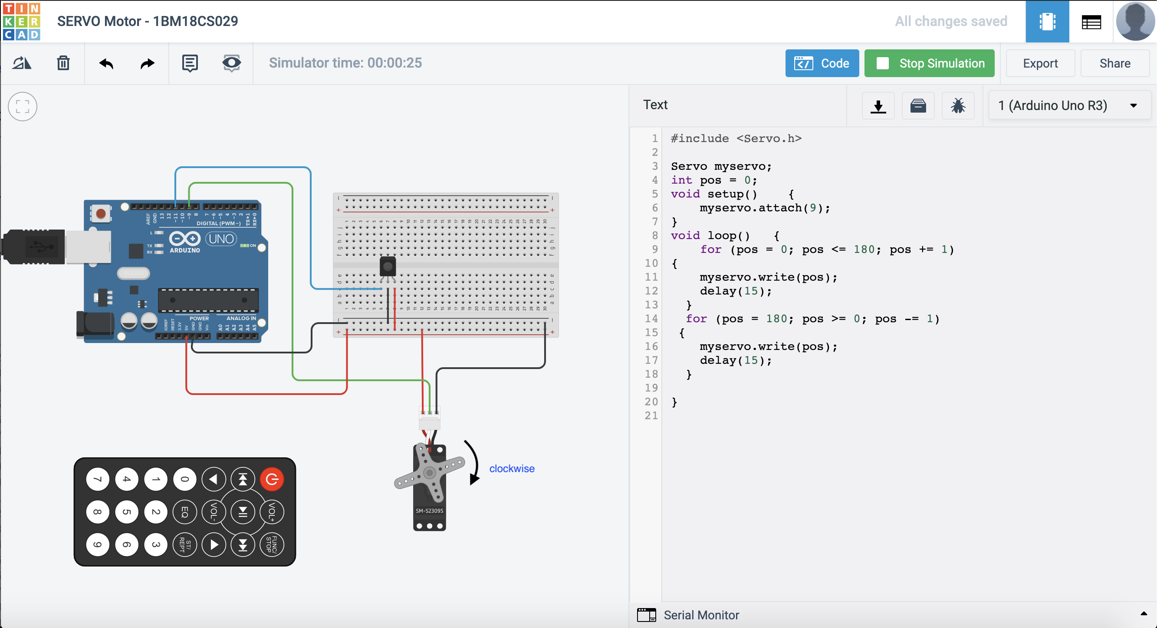

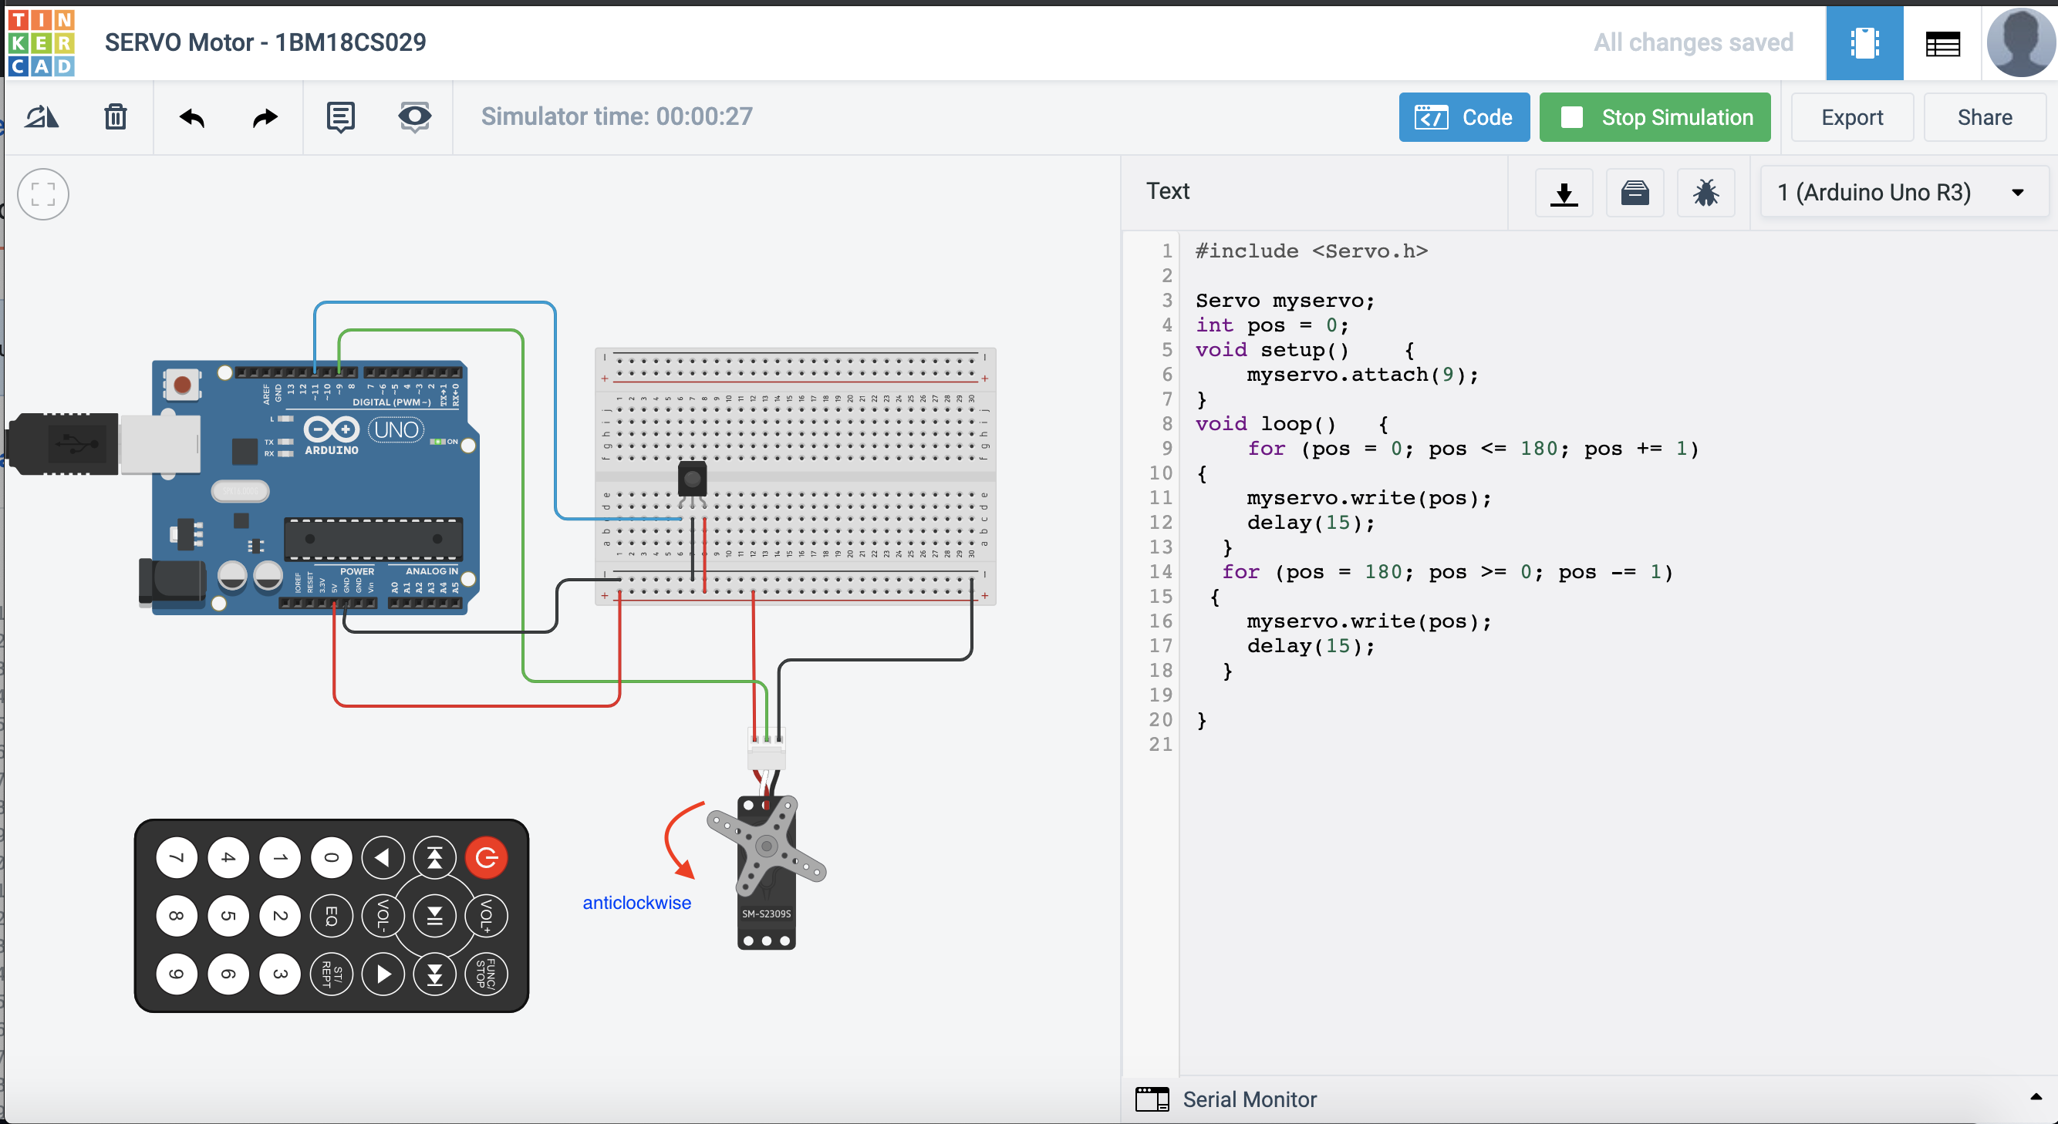

**Code:**

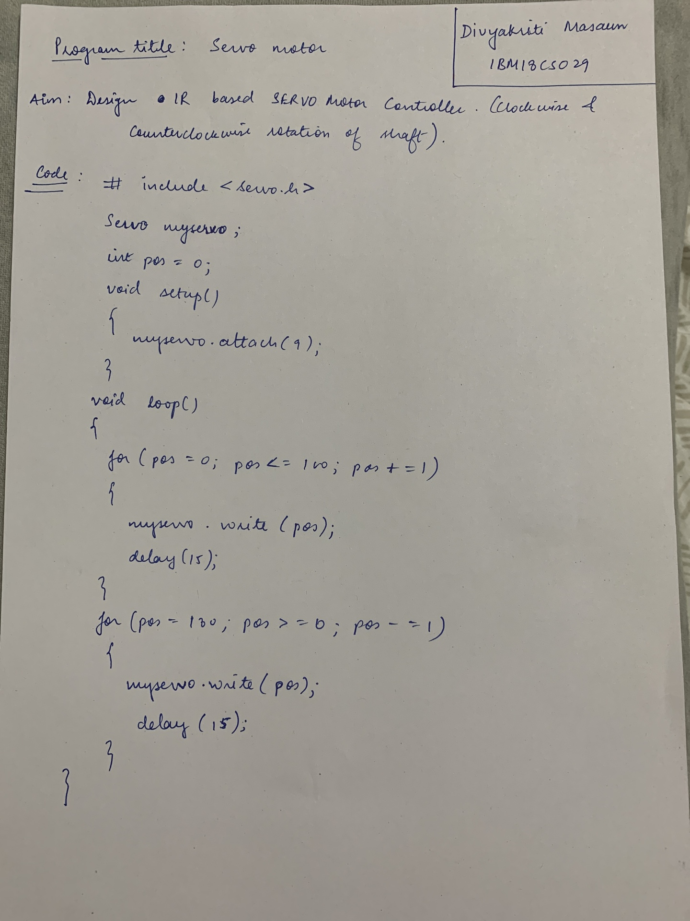

**Observation :**

Shaft rotates in Clockwise and Anticlockwise direction.